**Lab – 48: How to use Remote Desktop services in Windows 10?**

**Objective:** The objective of this lab is –

* To use Remote Desktop services in Windows 10.

Use Remote Desktop on your Windows 10 PC or on your Windows, Android, or iOS device to connect to a PC from afar. In this lab, we are going to remotely connect Windows 10 PC by using Windows machine.

**Prerequisite:** Windows 10 machines with Remote Desktop Connections On.

**Steps:**

1. First, you'll need to set up the remote PC to allow remote connections.
2. On the remote PC, open **Settings,** by clicking the **Settings** **icon ** an and select **System** > **About**. Note the **PC name**. You'll need this later.

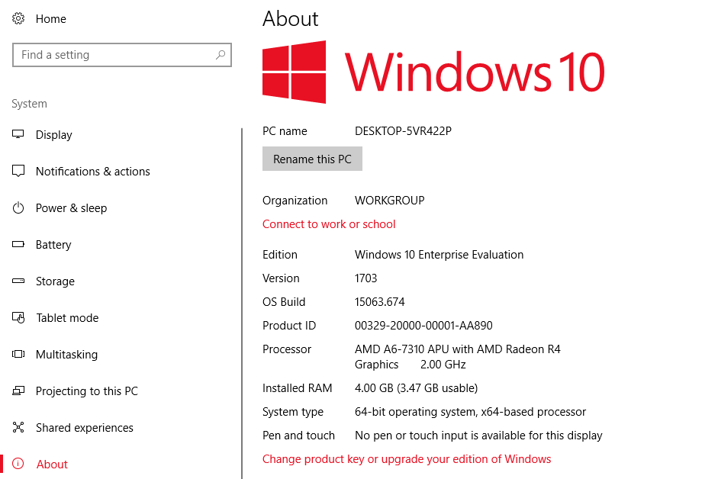

1. Then, under **Related settings**, select **System info**.

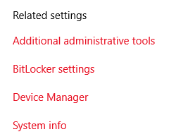

1. In the left pane of the **System** window, select **Advanced system settings**.

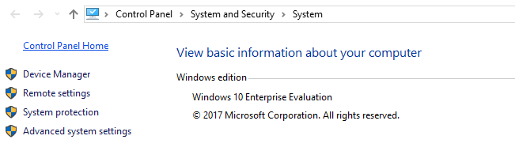

1. On the **Remote** tab of the **System Properties** dialog box, under **Remote Desktop**, select **Allow remote connections to this computer**, and then select **Apply** then **OK**.

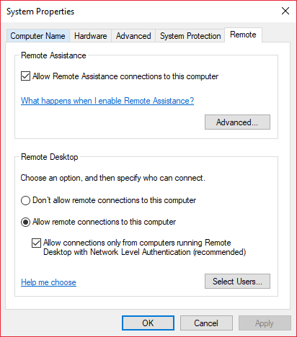

1. Next, in **Settings** select **System** **> Power & sleep** and check to make sure **Sleep** is set to **Never**.

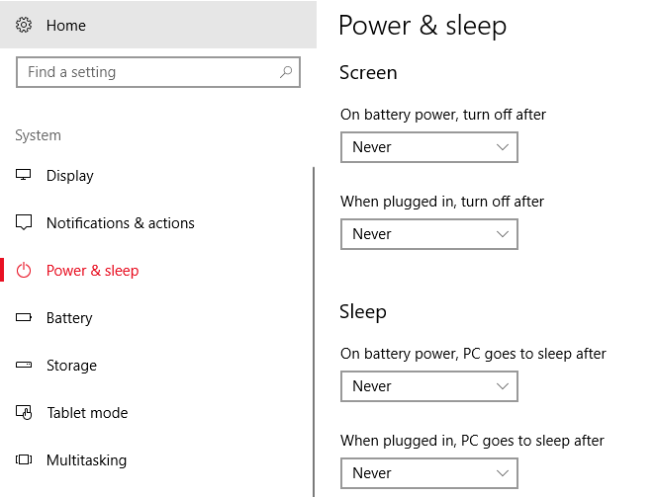

1. Then on your local Windows 10 PC: In the search box on the taskbar, type **Remote Desktop Connection**, and then select **Remote Desktop Connection**.
2. In Remote Desktop Connection, type the full name of the **remote PC**, and select **Connect**.

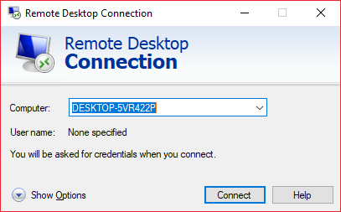

1. When you click Connect, it will ask you for the Computer Name/Email Address and Password. Enter the credentials of the Remote Machine and click **OK**.

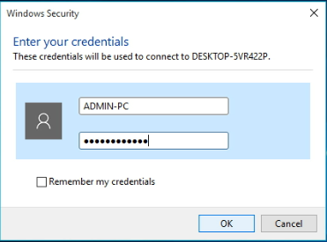

1. A warning pop-up box may appear, which says **The Identity of the remote computer cannot be verified. Do you want to connect anyway?** Click **Yes**.

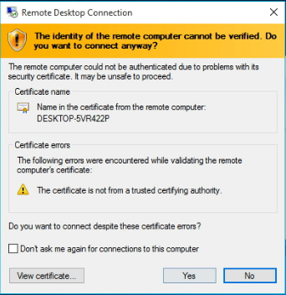

1. Then the remote service will connect your machine to the remote machine.

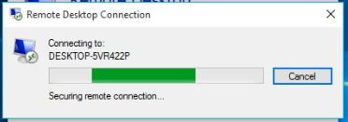

1. And, now you will be connected to the remote machine.

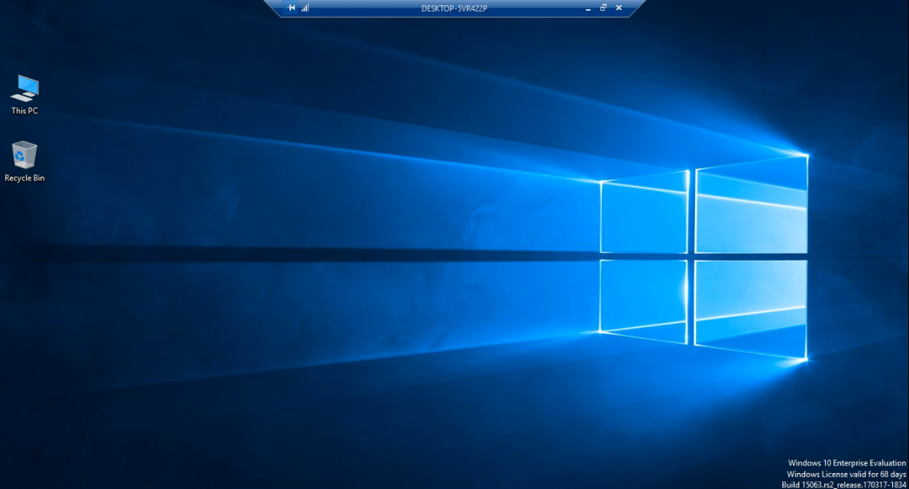

1. On the remote PC, you can open **Settings**, by clicking the Settings icon and select **System** > **About**, to check the remote PC details.
2. At the top of the screen you can see a connected Remote PC Name with Minimize, Restore Down and Close connection options.
3. So, by clicking Minimize you can minimize the Remotely connected PC and go back to your PC.



1. By clicking Restore Down you can manage the size of the connected PC as per your choice.

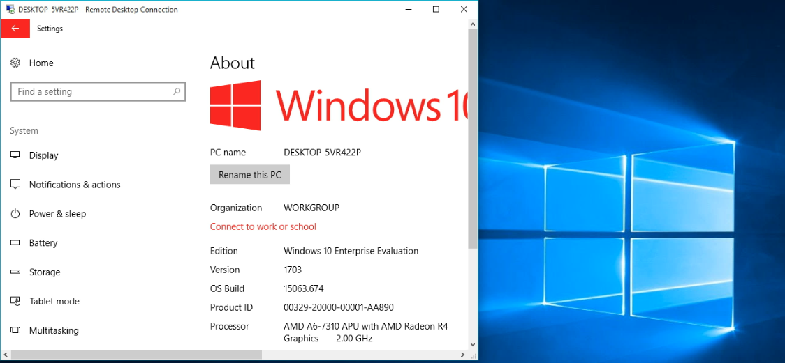

1. And, use Close button to close the connection.
2. So, in this way you can use Remote Desktop services in Windows 10.